

**Muddied Waters: The Ripple Effect of Small-Scale Mining on a River Ecosystem of Barangay Mamis, Barobo, Surigao del Sur**

A Project Proposal submitted by:

Cañedo, Felipe

Danlag, Rubelyn D.

Noquil, Jeobil Ralph

Suangco, Diane

Uriarte, Clydi Jean S.

Proposed Instructor:

Sir Rolymejan S. Amante

May 24, 2024

**II. Executive Summary**

The proposal aims to provide a comprehensive understanding of how small-scale mining affects river ecosystems. By documenting the extent of water pollution, and habitat disruption, the study can highlight the critical areas needing conservation efforts.

It emphasizes the interconnectedness of river ecosystems, showing how even small-scale activities can have large-scale environmental consequences.

By investigating the impact on aquatic life, the study can help in formulating strategies to preserve biodiversity. Understanding which species are most affected can guide targeted conservation efforts.

The proposal underscores the importance of clean water for community health. By detailing the health risks associated with mining-related water contamination, it can raise awareness and prompt actions to protect vulnerable populations.

The study recognizes that many communities depend on rivers for their livelihoods, including fishing and agriculture. Documenting the economic impact of river degradation can support efforts to find alternative, sustainable income sources for these communities.

**III. Introduction**

Small-scale mining is the process of extracting minerals from the earth using simple tools and methods. It is common in many developing countries and provides livelihoods for many people. However, it also has serious effects on the environment, especially river ecosystems.

In various parts of Africa, South America, and Southeast Asia, small-scale mining has significantly damaged river ecosystems. For example, in the Amazon basin, mercury from gold mining has polluted many rivers, affecting both wildlife and local communities. A study found that 76.5% of fish caught in the Amazon contained mercury levels above safe consumption limits set by the WHO. Similar problems are seen in African countries like Ghana and Zimbabwe, where small-scale mining is common. In Ghana, small-scale gold mining has led to mercury levels in some rivers being 200 times higher than safe limits.

It often involves using harmful chemicals like mercury and cyanide to extract minerals. These chemicals can get into rivers, contaminating the water. According to the United Nations Environment Programme (UNEP), artisanal and small-scale gold mining is the largest global source of mercury pollution, releasing approximately 1,400 tons of mercury annually into the environment.

The mining process also releases large amounts of sediment into rivers. A study by the World Wildlife Fund (WWF) found that sedimentation from mining activities increases river turbidity by 200-300%, drastically reducing water quality and affecting aquatic life.

Mining activities often change the physical structure of rivers and surrounding areas. For example, digging for minerals can destroy riverbeds and the homes of many aquatic creatures. The Global Water Forum reports that riverbank erosion due to mining can increase by up to 500%, leading to significant habitat loss.

Fish populations decline due to polluted water and loss of breeding grounds, disrupting the entire food chain in the river ecosystem. In Peru’s Madre de Dios region, small-scale gold mining has led to the decline of several fish species, affecting both the ecosystem and local fishing communities.

In Barangay Mamis, Barobo, Surigao del Sur, their river is one of their because here's where they get food and this river is also used as a laundry before because of its clean water. But now that a small-mining has emerged here, it seems like the color of the water is like a chocolate, very dirty and there is no fish living in it. And the water of the river will be loosened because they block the flow of water.

People living near small-scale mining sites often rely on river water for drinking and bathing. Polluted water poses serious health risks, including exposure to toxic chemicals that can cause long-term health problems. The World Health Organization (WHO) reports that millions of people are affected by mercury poisoning in mining areas, with symptoms ranging from cognitive impairments to severe organ damage. While small-scale mining provides jobs, it often traps communities in a cycle of poverty. The environmental damage caused by mining can destroy other sources of income, such as fishing and agriculture. Research by the International Labour Organization (ILO) indicates that 90% of the workforce in the small-scale mining sector lives in poverty.

**IV. Methodology and Approach**

To effectively study and mitigate the impact of small-scale mining on river ecosystems, a comprehensive and multidisciplinary methodology will be employed. This methodology will involve data collection, analysis, community engagement, and the implementation of sustainable practices.

The researchers will conduct surveys and interviews with local communities to gather data on health impacts, economic dependence on mining, and access to clean water.

Advocate for policies that support sustainable mining practices and provide incentives for compliance.

**V. Scope of the Project Proposal**

This project aims to comprehensively understand and mitigate the environmental and socio-economic impacts of small-scale mining on river ecosystems in Barangay Mamis, Barobo, Surigao del Sur.

It encompasses the following key areas:

* The project will investigate the health impacts of polluted water on local communities, focusing on issues such as mercury poisoning and other waterborne diseases.
* The dependence of local communities on small-scale mining for their livelihoods will be assessed, along with the economic costs of environmental degradation.
* Introduce and promote the adoption of cleaner mining technologies that minimize environmental damage.
* Provide training and educational workshops to miners and community members on sustainable practices and alternative livelihoods.
* Use media and outreach activities to raise public awareness about the impacts of small-scale mining and the importance of sustainable practices.

**VI. Timeline or Schedule**

| **Month** | **Key Activities** | **Deliverables** |
| --- | --- | --- |
| 1-3 | Project Kickoff, Site Selection, Baseline Data Collection | Project plan, site list, baseline data |
| 4-6 | Environmental and Socio-Economic Data Collection | Water quality reports, survey data |
| 7-9 | Data Analysis and Initial Reporting | Environmental and socio-economic reports |
| 10-12 | Community Engagement and Education | Stakeholder reports, workshop evaluations |
| 13-15 | Implementation of Sustainable Practices | Technology adoption reports, rehab plans |
| 16-18 | Monitoring and Evaluation Setup | Monitoring protocols, mid-project evaluation |
| 19-21 | Policy Advocacy and Development | Policy proposals, partnership agreements |
| 22-24 | Final Reporting and Dissemination | Final reports, publications, dissemination activities |

This timeline ensures that the project progresses methodically through each phase, allowing for thorough data collection, analysis, community engagement, and implementation of sustainable practices. Regular milestones and deliverables will help track progress and ensure the project stays on schedule.

**VII. Budget**

The budget for this 24-month project is designed to cover all aspects from initial planning and data collection to community engagement, implementation of sustainable practices, and final reporting.

* **Fieldwork Expenses**

1. **Equipment Rental (sampling, surveying): ₱7,000.00/year**

* **Workshops and Meetings**

**2) Materials and Supplies: ₱4,000.00/year**

**3) Venue Rentals: ₱1,500.00/year**

* **Technology and Training**

**4) Cleaner Mining Technology ₱19,000.00/one-time cost**

**5) Training Programs ₱10,000.00/year**

* **Monitoring Equipment**

**6) Water Quality Sensors ₱11,000.00/one-time cost**

**7) Monitoring Tools ₱6,000.00/one-time cost**

* **Unexpected Cost ₱20,000.00/year**

**Total Project Budget: ₱78,500.00**

**Funding Resources**

* **Local and National Government- Request support from government, responsible for environmental protection and sustainable development.**
* **Online Campaigns- Launch crowdfunding campaigns on social media platforms to attract public support.**

**Transparency and Financial Feasibility**

* **Regular Financial Reporting- Provide a quarterly financial report to all stakeholders and funding bodies, detailing expenditure and remaining funds.**
* **Audit- Conduct annual audits by an independent auditor like the Brgy. Treasurer to ensure funds are used appropriately and efficiently.**
* **Public Disclosure- Publish financial summaries and project progress on the project and through regular letters to keep the stakeholders informed.**

**VIII. Evaluation Plan**

**Evaluation Objectives**

1. **Evaluate Socio-Economic Impact: Measures the socio-economic benefits to the local communities, including health improvements and economic gains from sustainable practices.**

**Key Performance Indicator:**

* **Decrease in health issues related to mining pollution.**
* **Increase in income from sustainable livelihood alternatives.**
* **Number of community members trained and employed in sustainable practices.**

1. **Monitor Community Engagement: Gauge the level of community participation and awareness raised through the project.**

**Key Performance Indicator:**

* **Number of workshops and participants.**
* **Level of community satisfaction and feedback.**
* **Increase in community-led initiatives for environmental protection.**

1. **Track Implementation Success: Evaluate the adoption and effectiveness of cleaner mining technologies and site rehabilitation efforts.**

**Key Performance Indicator:**

* **Number of mining technologies and site rehabilitation efforts.**

1. **Ensure Policy Influence: Assess the influence of the project on local policy development.**

**Key Performance Indicator:**

* **Number of new revised policies influenced by the project.**
* **Engagement level of policymakers and government officials.**
* **Inclusion of project recommendations in Barangay development plans.**

**IX. Sustainability Plan**

**Ongoing Funding**

* **Government Grants and Supports**- Secure continued funding from local and national government agencies responsible for environmental protection and sustainable development.
* **Crowdfunding and Public Donations**- Maintain a crowdfunding platform and encourage public donations to support ongoing activities.

**Capacity Building**

* **Community Training**- Continue providing training programs for community members on sustainable mining practices, environmental conservation, and alternative livelihoods.
* **Local Leadership Development**- Identify and train local leaders to take over project management and monitoring roles, ensuring community ownership and self-sufficiency.

**Partnerships**

* **Government Agencies**- Establish formal agreements with government agencies to ensure continued support and integration of project activities into policies and programs.
* **Non-Governmental Organizations (NGOs)**- Collaborate with local and international NGOs that have expertise in environmental conservation and community development for ongoing support and knowledge exchange.
* **Community Co-operatives**- Encourage the formation of community co-operatives focused on sustainable livelihoods, which can reinvest profits into community development projects.

**Community Engagement**

* **Ownership and Participation**- Foster a sense of ownership among community members by involving them in decision-making processes and project activities.
* **Ongoing Education Campaigns**- Continue educational campaigns to raise awareness about the importance of environmental conservation and sustainable practices.
* **Advocacy and Policy Influence**- Empower community members to advocate for environmental policies and regulations that support sustainable mining practices and ecosystem protection.

**Monitoring and Evaluation**

* **Local Monitoring Teams**- Establish local monitoring teams trained in environmental and socio-economic data collection to ensure continuous monitoring of the project’s impact.
* **Regular Reporting**- Implement a system for regular reporting and feedback, allowing for adaptive management and timely interventions as needed.
* **Periodic Evaluations**- Conduct periodic evaluations to assess the long-term impact of the project and make necessary adjustments.
* **Sustainability Indicators**- Develop and track specific sustainability indicators to measure the ongoing health of the river ecosystem and the socio-economic well-being of the community.

**X. Conclusion**

Small-scale mining, while providing essential livelihoods for many, poses significant threats to river ecosystems and the surrounding communities. This project that we proposed seeks to address these challenges through a comprehensive, multi-faceted approach. This initiative is designed to mitigate the environmental damage caused by mining activities, improve the socio-economic conditions of local communities, and foster sustainable practices that can be maintained long into the future. The initiative starts with a clear recognition of the issue: although small-scale mining is common and essential to many communities' economic survival, it frequently causes serious pollution and habitat degradation. Moreover, local ecosystems' natural balance has been disrupted by environmental degradation, which causes long-term ecological harm.

To address these issues, the project sets forth several key objectives. First, it aims to thoroughly assess the environmental impact of small-scale mining on river ecosystems through scientific research and data collection. This includes measuring pollutant levels, monitoring biodiversity, and evaluating soil and water quality. Second, it seeks to improve the socio-economic conditions of local communities by introducing and promoting sustainable livelihood alternatives. This involves training community members in sustainable practices, providing education on environmental conservation, and supporting the adoption of cleaner mining technologies. Third, the project emphasizes community engagement, raising awareness about the importance of environmental protection and involving locals in decision-making processes. Finally, it aims to influence policy by advocating for regulations that support sustainable mining practices and environmental conservation.

The project's methodology is comprehensive and strong, integrating socioeconomic and environmental evaluations. The existing state of the river environment and the socioeconomic circumstances of the surrounding villages will be determined by initial background surveys. After these surveys, there will be ongoing observation and mid-project reviews to assess development and make required modifications. In order to provide community people with the information and abilities to adopt and maintain cleaner mining methods, workshops and training programs will be organized.

We cannot emphasize the significance of this project enough. It attempts to create a more sustainable and healthy future for the communities impacted by small-scale mining by addressing its socioeconomic and environmental effects. An ecosystem will become more resilient if pollution is decreased, water quality is improved, and biodiversity is increased. The development of sustainable livelihoods will also benefit the local population's health and financial stability. These long-lasting benefits are ensured by the project's full and integrated approach, that supports a sustainable balance between environmental preservation and economic development.

We encourage to all interested parties to support this important project, including government agencies, non-governmental organizations, commercial sector partners, and the general public. In order to accomplish the project's objectives and secure a sustainable future for those whose lives are affected and ecosystems, your participation and funding are needed. When we work together, we can make a significant and long-lasting difference in the lives of individuals who depend on the environment.  
We cordially encourage your participation in this significant endeavor by means of donations, cooperation, and advocacy. With your help, we can put practical solutions into action, strengthen community capacity, and push for essential policy changes. Come together with us as we work to save our rivers, encourage sustainable means of survival, and build a better, more prosperous future for everybody.

**XI. Appendices**

Appendix A: Risk Management Plan

| **Risk** | **Potential Impact** | **Mitigation Strategy** |
| --- | --- | --- |
| **Funding Shortfalls** | Delays in project activities | Diversify funding sources, establish contingency funds |
| **Community Resistance** | Low participation and engagement | Increase community involvement, provide clear benefits and incentives |
| **Environmental Variability** | Inconsistent data and project impact | Use adaptive management practices, continuous monitoring |
| **Policy Changes** | Impact on project alignment and support | Regular communication with policymakers, flexible project adaptation |
| **Technical Challenges** | Delays in technology implementation | Partner with technical experts, provide additional training |

Appendix B: Communication Plan

| **Audience** | **Communication Channel** | **Frequency** | **Purpose** |
| --- | --- | --- | --- |
| **Local Communities** | Community meetings, newsletters, social media | Monthly | Keep informed, gather feedback, maintain engagement |
| **Government Agencies** | Reports, briefings, formal meetings | Quarterly | Provide updates, secure support, influence policy |
| **NGOs and Research Institutions** | Collaborative workshops | Ongoing | Share knowledge, enhance capacity, foster collaboration |
| **Private Sector Partners** | Corporate meetings, partnerships | Bi-annually | Secure funding, technical support |
| **International Donors** | Funding reports, progress updates, impact assessments | Bi-annually | Ensure transparency, demonstrate impact, secure continued support |

#### 

#### Documentation

#### MINING SITE

#### 

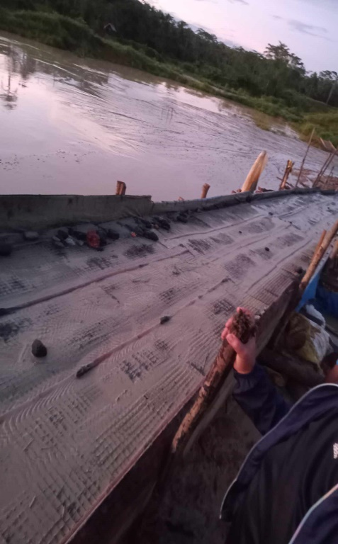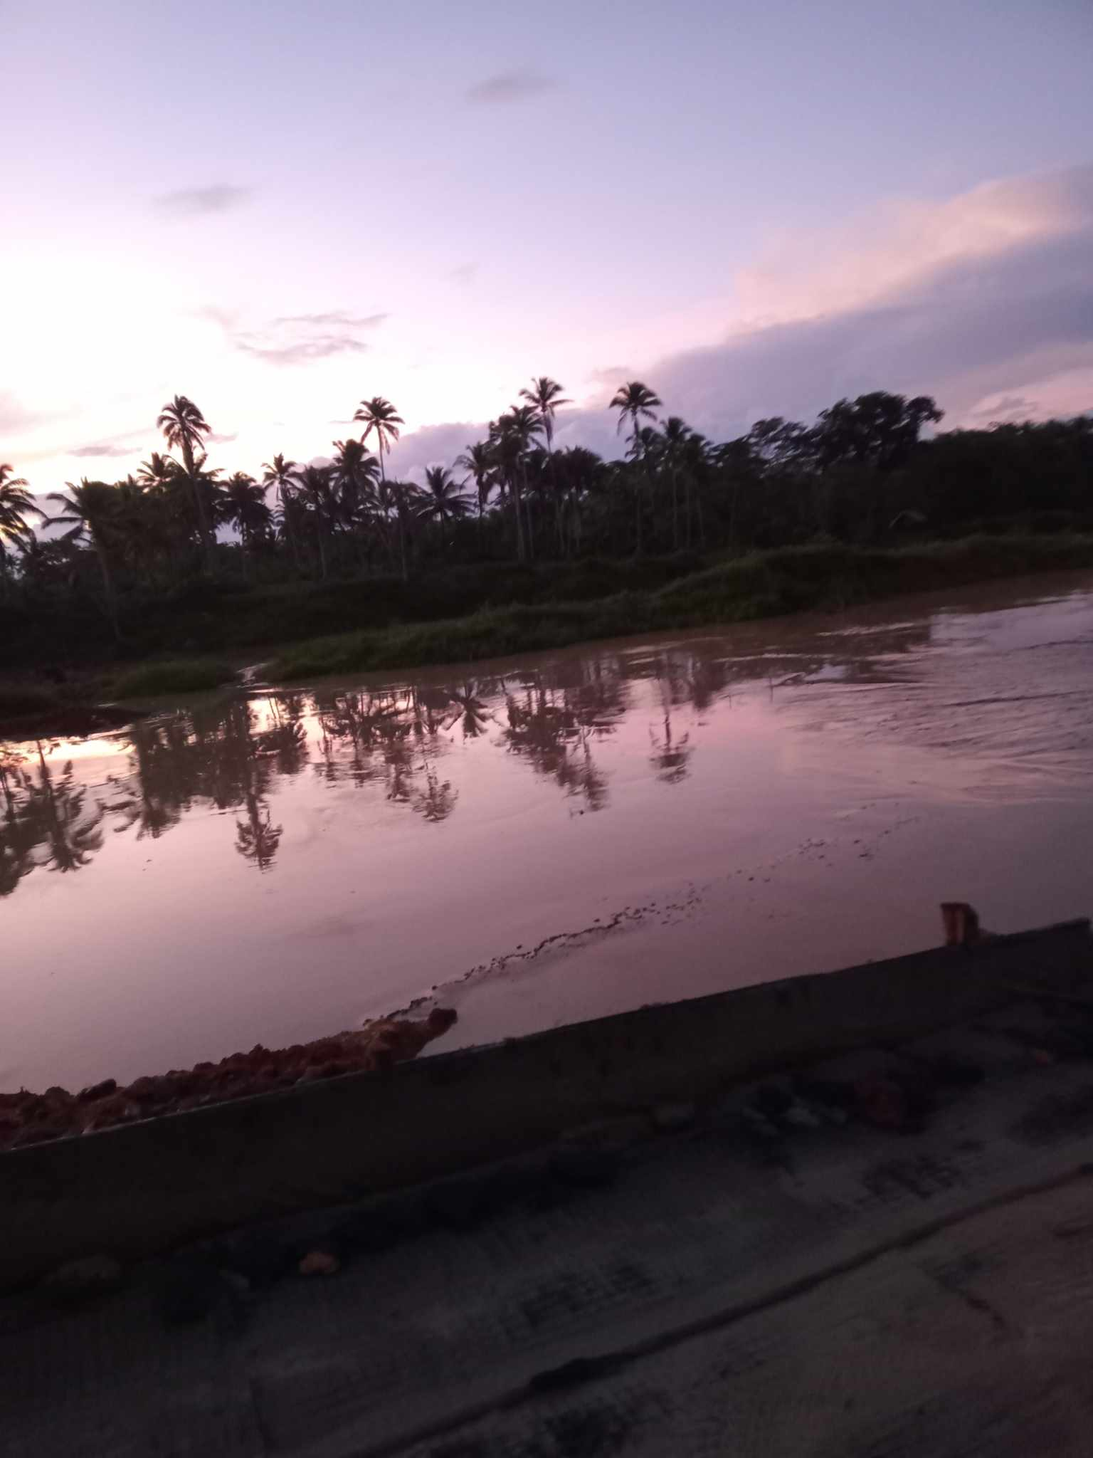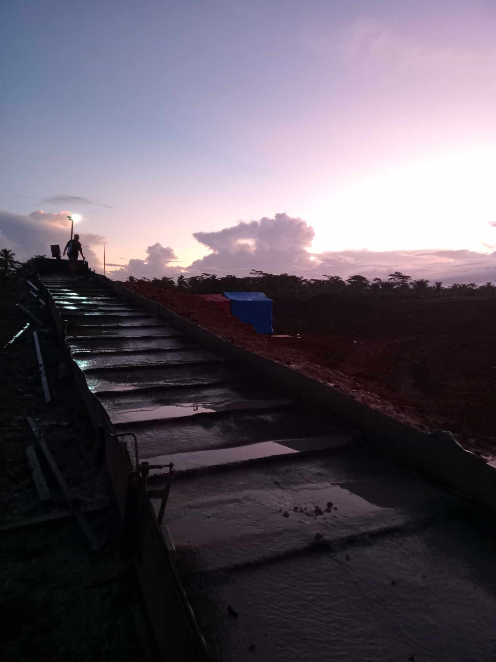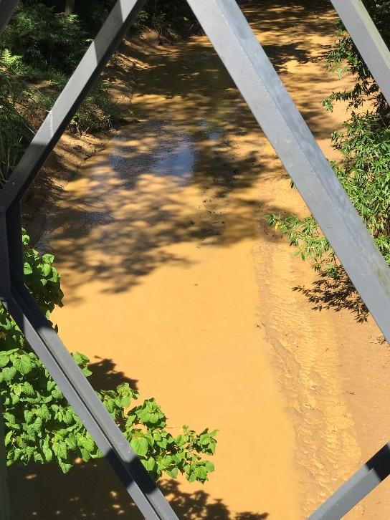**BARANGAY MAMIS RIVER**

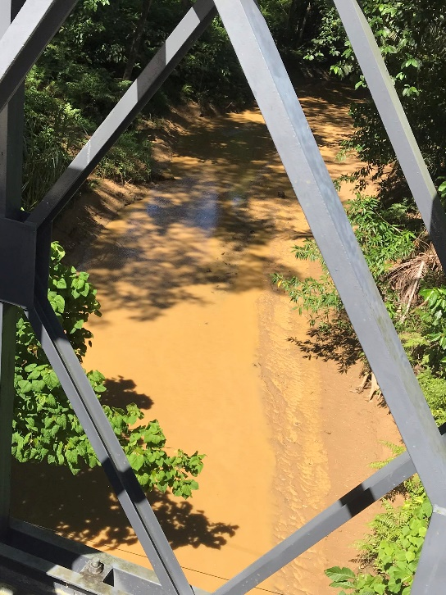

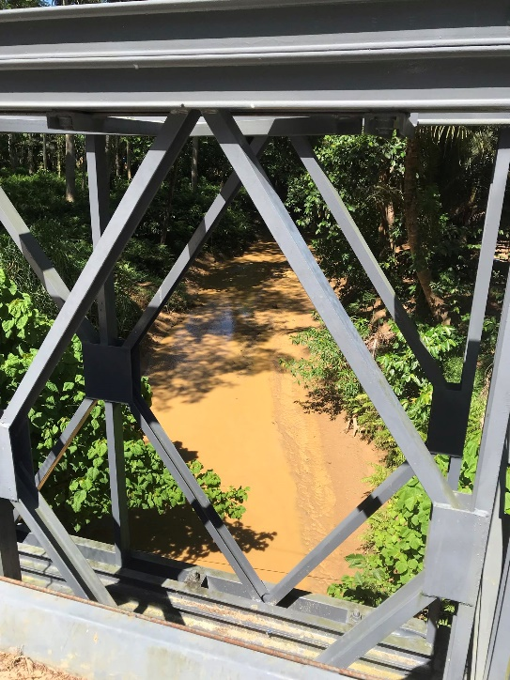

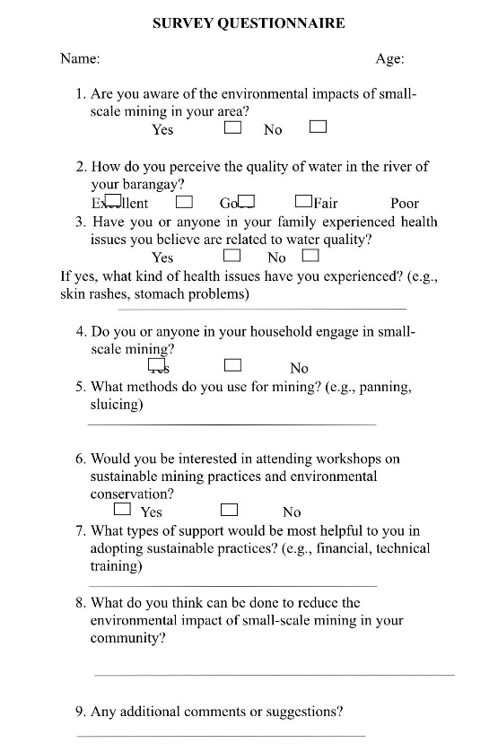**SURVEYS**

